Smart Home System (use style: paper title)

*Note: Sub-titles are not captured in Xplore and should not be used

line 1: 1st Given Name Surname   
line 2: *dept. name of organization   
(of Affiliation)*  
line 3: *name of organization   
(of Affiliation)*line 4: City, Country  
line 5: email address or ORCID

line 1: 4th Given Name Surname  
line 2: *dept. name of organization*  
*(of Affiliation)*  
line 3: *name of organization   
(of Affiliation)*line 4: City, Country  
line 5: email address or ORCIDline 1: 2nd Given Name Surname  
line 2: *dept. name of organization   
(of Affiliation)*  
line 3: *name of organization   
(of Affiliation)*line 4: City, Country  
line 5: email address or ORCID

line 1: 5th Given Name Surname  
line 2: *dept. name of organization   
(of Affiliation)*  
line 3: *name of organization   
(of Affiliation)*line 4: City, Country  
line 5: email address or ORCIDline 1: 3rd Given Name Surname  
line 2: *dept. name of organization   
(of Affiliation)*  
line 3: *name of organization   
(of Affiliation)*line 4: City, Country  
line 5: email address or ORCID

line 1: 6th Given Name Surname  
line 2: *dept. name of organization   
(of Affiliation)*  
line 3: *name of organization   
(of Affiliation)*line 4: City, Country  
line 5: email address or ORCID

*Abstract*—This paper introduces Smart Home System that includes four main components which are Smart Lamp, Smart Heating and Cooling, Smart Fire Alarm and lastly Smart Door Lock. Source of the image and type of image also will be explained in this paper to make the reader more understand about our Smart Home System works . This article contains a few images and table to make the explanation more understandable. *Do Not Use Symbols, Special Characters, Footnotes, or Math in Paper Title or Abstract*. (*Abstract*)

Keywords—component, formatting, style, styling, insert (key words)

# Introduction (*Heading 1*)

This template, modified in MS Word 2007 and saved as a “Word 97-2003 Document” for the PC, provides authors with most of the formatting specifications needed for preparing electronic versions of their papers. All standard paper components have been specified for three reasons: (1) ease of use when formatting individual papers, (2) automatic compliance to electronic requirements that facilitate the concurrent or later production of electronic products, and (3) conformity of style throughout a conference proceedings. Margins, column widths, line spacing, and type styles are built-in; examples of the type styles are provided throughout this document and are identified in italic type, within parentheses, following the example. Some components, such as multi-leveled equations, graphics, and tables are not prescribed, although the various table text styles are provided. The formatter will need to create these components, incorporating the applicable criteria that follow.

# Ease of Use

## Selecting a Template (Heading 2)

First, confirm that you have the correct template for your paper size. This template has been tailored for output on the A4 paper size. If you are using US letter-sized paper, please close this file and download the Microsoft Word, Letter file.

## Maintaining the Integrity of the Specifications

The template is used to format your paper and style the text. All margins, column widths, line spaces, and text fonts are prescribed; please do not alter them. You may note peculiarities. For example, the head margin in this template measures proportionately more than is customary. This measurement and others are deliberate, using specifications that anticipate your paper as one part of the entire proceedings, and not as an independent document. Please do not revise any of the current designations.

# Prepare Your Paper Before Styling

Before you begin to format your paper, first write and save the content as a separate text file. Complete all content and organizational editing before formatting. Please note sections A-D below for more information on proofreading, spelling and grammar.

Keep your text and graphic files separate until after the text has been formatted and styled. Do not use hard tabs, and limit use of hard returns to only one return at the end of a paragraph. Do not add any kind of pagination anywhere in the paper. Do not number text heads-the template will do that for you.

## Abbreviations and Acronyms

Define abbreviations and acronyms the first time they are used in the text, even after they have been defined in the abstract. Abbreviations such as IEEE, SI, MKS, CGS, sc, dc, and rms do not have to be defined. Do not use abbreviations in the title or heads unless they are unavoidable.

## Units

* Use either SI (MKS) or CGS as primary units. (SI units are encouraged.) English units may be used as secondary units (in parentheses). An exception would be the use of English units as identifiers in trade, such as “3.5-inch disk drive”.
* Avoid combining SI and CGS units, such as current in amperes and magnetic field in oersteds. This often leads to confusion because equations do not balance dimensionally. If you must use mixed units, clearly state the units for each quantity that you use in an equation.
* Do not mix complete spellings and abbreviations of units: “Wb/m2” or “webers per square meter”, not “webers/m2”. Spell out units when they appear in text: “. . . a few henries”, not “. . . a few H”.

Identify applicable funding agency here. If none, delete this text box.

## Smart Home Fire Alarm System

Fires almost always occur in homes in consequence of carelessness and changes in environmental conditions. That is why fire safety is one of the major concerns for a safe home environment. In recent years, fire detection has become a very big issue, as it has caused severe damage including the loss of human lives. Sometimes, these incidents are more destructive when the fire spreads to the surroundings [2]. In the present circumstances, fires can get out of control because people intend to save money rather than installing proper fire alarm systems.

Study shows that, in the United States, fire is the fourth largest accidental killer behind motor vehicle accidents, falls, and drownings. It is also the disaster that families are mostly likely to experience. Over 80 percent of all fire deaths occur where people sleep, such as in homes or hotels. Most fires occur when people are likely to be less alert such as between midnight and morning. Approximately three-quarters of all fire fatalities occur in residential dwellings. On average in the United States, fires kill nearly 5,500 Americans each year. Over 30,000 people are injured in fires annually and someone dies in a fire every 40 minutes. Most often, victims are children or the elderly. Approximately 1,300 senior citizens die in fires annually. Each year, fire causes over $2 billion worth of damage to homes [1].

Protecting your family from fire requires advance planning for what to do if fire strikes. This includes the use of protective devices, usually smoke alarms, to provide early warning of fire, especially at night when they are most vulnerable.

Early detection of a fire event is an effective way to save lives and reduce property damage. To escape a fiery place and to extinguish the fire source, the fire must be detected at its initial stage. The installation of a fire alarm system is the most convenient way to detect a fire early and avoid losses. A fire alarm system includes components operating together to detect and alarm people by visual and audio methods when smoke, fire, or other dangers are occurred [2]. It also can notify the fire department and control all the fire alarm devices in the area.

Smoke detectors save lives and can help minimize property damage, but what happens when the alarm goes off when nobody is home? [3] In accordance to this problem, we have come out with Smart Fire Alarm System with Automatic Water sprinkler that has been developed to solve the slow response issue of fire accidents. The system reads the heat and smoke data using IoT, analyses these data, and then quickly triggers the automatic water sprinkler. The inputs provide readings for the system to analyse, such as sensors and Wi-Fi module that works as a transmitter for the sensor readings. Temperature and gas sensors are inputs [5]. The readings from the inputs are displayed on the LCD.

Outputs like LED and Buzzer indicate a fire. The water system is supplied with a 12V water pump powered by Arduino and Controlled by a 5V relay. The sprinkler head is the outer of the water output. The alarm is also wired into the fire and smoke detectors and the sprinkler system. The alarm system itself is fault tolerant, has its own internal backup power supply, and is encased in a fireproof box [4] On account of this, our study's importance is to provide a low-cost fire alarm system considering the affordability, effectiveness, and responsiveness.

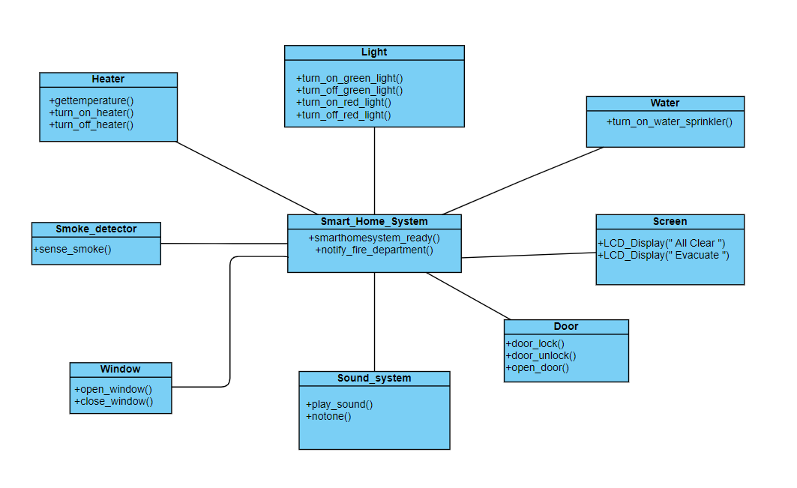

1. Figure above shows the class diagram for the Smart Fire Alarm System.

As we can see, there are seven main components connected to the main Smart Home System and the components are:

* Smoke detector
* Heater (which also includes temperature sensor)
* Water sprinkler
* Screen (LCD)
* Window
* Sound system
* Door

All of the stated components will respond or react correspondingly to the surroundings and perform their respective functions based on the situation. The concept is simple, a fire alarm system that tells us that there is a fire nearby is great, but the ones that tells us that there is a fire and reacts upon the fire in immediate effect is undoubtedly even better.

We know that each component of a smart home system is designed to be used in a specific location. In the following parts, we will explore more on the components detail, discover how smoke detectors work and where they are located.

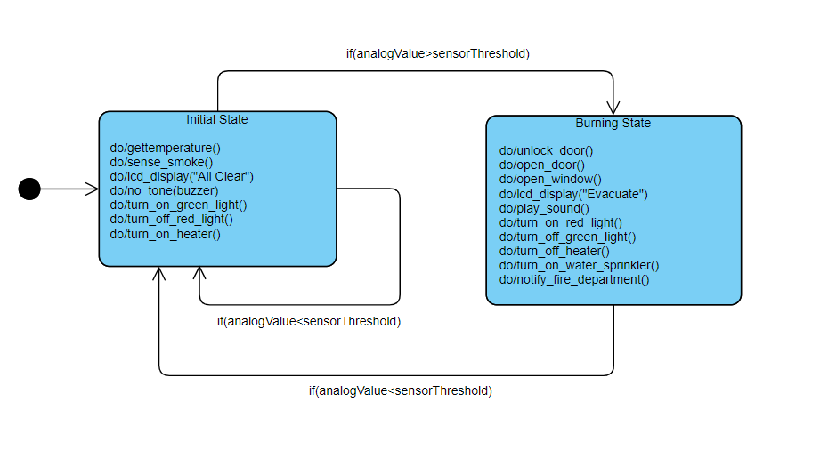

1. Figure above shows the state diagram for the Smart Fire Alarm System.

House combustion is one of the main concerns for builders, designers, and property residents. Singular sensors were used for a long time in the event of detection of a fire, but these sensors cannot measure the amount of fire to alert the emergency response units. To address this problem, as stated earlier, this study also aims to implement a smart fire detection system that would not only detect the fire using integrated sensors but also alert property owners, emergency services, and local fire department stations to protect lives and valuable assets simultaneously [5].

The proposed model in this paper employs different integrated detectors, such as heat and smoke detector. The signals from those detectors go through the system algorithm to check the fire's potentiality and then broadcast the predicted result to various parties using Global System for Mobile Communications (GSM) modem associated with the system. To get real-life data without putting human lives in danger, an IoT technology has been implemented to provide the fire department with the necessary data making this system more reliable. The experimental results showed the superiority of our model in terms of affordability, effectiveness, and responsiveness as the system uses the Ubidots platform, which makes the data exchange faster and reliable [5].

Location and material requirements consideration when designing a smart fire alarm system are:

* For all new home construction, fire alarm sensors must be powered by the home AC power electrical wiring. Although this overcomes the problem of neglecting to replace batteries on a periodic basis, there remains the problem of power outages that would also disable a fire warning sensor that uses the home wiring as a power source [6].
* For homes built prior to 1979, battery-powered smoke alarms are permissible. In newer dwellings, alarms must be powered by the electrical wiring. The problem with battery units is that people often neglect battery replacement. On the other hand, what good are wired-in smoke alarms if we have an electrical fire accompanied by a power outage? The safest arrangement, therefore, is to install wired-in alarms equipped with battery backup. Batteries feed the system as a back-up source while the primary Alternating Current (AC) source function [6].
* As to smoke alarm placement, requirements also vary according to the age of the dwelling. In older homes, most municipalities require alarms in the locations of within a close proximity to all bedroom entrances, on each storey of a multilevel home, and in basements. The latest standards, enacted in 1993, require that there be an additional alarm in each bedroom. Another practical location, although not required, is the garage [6].

Next, we will go deeper on the explanation behind the state machine diagram given in figure 2. Furthermore, the basic implementation of the smart fire alarm is realised by using the Tinkercad platform to take a glimpse on how the smart fire alarm really works in respective situations and conditions. To ease our understandings on the functionalities and responds of this system, we will use the approach with the help of illustration using some diagrams and pictures which we will explain later.

Based on the state machine diagram in figure 2, we can see that there are two state which are Initial State and Burning State. The transition between the states only depends on the analogue value of the sensor. If the analogue value exceeds the sensor’s threshold value, it will go to the burning state where the action of opening the window and door, turning off the heater to reduce the surrounding temperature, turning on the water sprinkler and notify the fire department nearby. The other features of the system will be explained more afterwards using some snaps of photos during the simulation on Tinkercad.

Subsequently, the implementation of the circuit below does not really imply all the detailed components that were supposed to be in the system itself, but rather an adaptation of a simple circuit sample aims for a clearer interpretation of the system implementation.

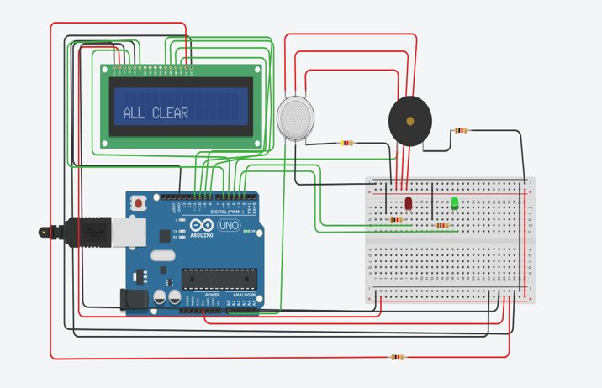

1. Figure above shows the example simple circuit for the Smart Fire Alarm System when no burning is detected.

Notice that when there is no fire or burning detected in any area of the smart home, the LCD screen displays “All Clear” and the green LED is turned on meanwhilst the red LED and the buzzer stayed turn off.

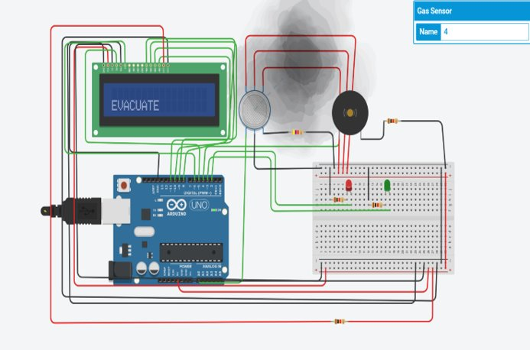

1. Figure above shows the example simple circuit for the Smart Fire Alarm System when there is fire detected.

Meanwhile, when there is fire or burning detected in any area of the smart home, the LCD screen will be displaying “Evacuate” and the green LED will turn off. Subsequently, the red LED will turn on and the buzzer will play sound to indicate there is emergency or wake the home owner up in case that the inhabitants are sleeping, since most fire deaths occur where people sleep such as between midnight and morning. This aims to warn the home owner or person living at the home that there is a fire and take particular act or precaution.

subheads should be introduced. Styles named “Heading 1”, “Heading 2”, “Heading 3”, and “Heading 4” are prescribed.

## Figures and Tables

#### Positioning Figures and Tables: Place figures and tables at the top and bottom of columns. Avoid placing them in the middle of columns. Large figures and tables may span across both columns. Figure captions should be below the figures; table heads should appear above the tables. Insert figures and tables after they are cited in the text. Use the abbreviation “Fig. 1”, even at the beginning of a sentence.

1. Table Type Styles

| Table Head | Table Column Head | | |
| --- | --- | --- | --- |
| Table column subhead | Subhead | Subhead |
| copy | More table copya |  |  |

1. Sample of a Table footnote. (*Table footnote*)
2. Example of a figure caption. (*figure caption*)

Figure Labels: Use 8 point Times New Roman for Figure labels. Use words rather than symbols or abbreviations when writing Figure axis labels to avoid confusing the reader. As an example, write the quantity “Magnetization”, or “Magnetization, M”, not just “M”. If including units in the label, present them within parentheses. Do not label axes only with units. In the example, write “Magnetization (A/m)” or “Magnetization {A[m(1)]}”, not just “A/m”. Do not label axes with a ratio of quantities and units. For example, write “Temperature (K)”, not “Temperature/K”.

##### Affidavit *(Heading 5)*

The preferred spelling of the word “acknowledgment” in

##### References

The template will number citations consecutively within brackets [1]. The sentence punctuation follows the bracket [2]. Refer simply to the reference number, as in [3]—do not use “Ref. [3]” or “reference [3]” except at the beginning of a sentence: “Reference [3] was the first ...”

Number footnotes separately in superscripts. Place the actual footnote at the bottom of the column in which it was cited. Do not put footnotes in the abstract or reference list. Use letters for table footnotes.

Unless there are six authors or more give all authors’ names; do not use “et al.”. Papers that have not been published, even if they have been submitted for publication, should be cited as “unpublished” [4]. Papers that have been accepted for publication should be cited as “in press” [5]. Capitalize only the first word in a paper title, except for proper nouns and element symbols.

For papers published in translation journals, please give the English citation first, followed by the original foreign-language citation [6].

1. G. Eason, B. Noble, and I. N. Sneddon, “On certain integrals of Lipschitz-Hankel type involving products of Bessel functions,” Phil. Trans. Roy. Soc. London, vol. A247, pp. 529–551, April 1955. *(references)*
2. J. Clerk Maxwell, A Treatise on Electricity and Magnetism, 3rd ed., vol. 2. Oxford: Clarendon, 1892, pp.68–73.
3. I. S. Jacobs and C. P. Bean, “Fine particles, thin films and exchange anisotropy,” in Magnetism, vol. III, G. T. Rado and H. Suhl, Eds. New York: Academic, 1963, pp. 271–350.
4. K. Elissa, “Title of paper if known,” unpublished.
5. R. Nicole, “Title of paper with only first word capitalized,” J. Name Stand. Abbrev., in press.
6. Y. Yorozu, M. Hirano, K. Oka, and Y. Tagawa, “Electron spectroscopy studies on magneto-optical media and plastic substrate interface,” IEEE Transl. J. Magn. Japan, vol. 2, pp. 740–741, August 1987 [Digests 9th Annual Conf. Magnetics Japan, p. 301, 1982].
7. M. Young, The Technical Writer’s Handbook. Mill Valley, CA: University Science, 1989.

**IEEE conference templates contain guidance text for composing and formatting conference papers. Please ensure that all template text is removed from your conference paper prior to submission to the conference. Failure to remove template text from your paper may result in your paper not being published.**

We suggest that you use a text box to insert a graphic (which is ideally a 300 dpi TIFF or EPS file, with all fonts embedded) because, in an MSW document, this method is somewhat more stable than directly inserting a picture.

To have non-visible rules on your frame, use the MSWord “Format” pull-down menu, select Text Box > Colors and Lines to choose No Fill and No Line.